**Assignment 8**

10.23

10.28

10.45

11.37

11.38

**10.23 Beer and blood alcohol.**

How well does the number of beers a student drinks predict his or her blood alcohol content (BAC)? Sixteen student volunteers at Ohio State University drank a randomly assigned number of 12-ounce cans of beer. Thirty minutes later, a police officer measured their BAC. Here are the data

The students were equally divided between men and women and differed in weight and usual

drinking habits. Because of this variation, many students don’t believe that number of drinks

predicts BAC well. **BAC**

(a) Make a scatterplot of the data. Find the equation of the least-squares regression line for

predicting BAC from number of beers and add this line to your plot. What is *r*2 for these data?

Briefly summarize what your data analysis shows.

(b) Is there significant evidence that drinking more beers increases BAC on the average in the

population of all students? State hypotheses, give a test statistic and *P*-value, and state your

conclusion.

(c) Steve thinks he can drive legally 30 minutes after he drinks 5 beers. The legal limit is BAC =

0.08. Give a 90% prediction interval for Steve’s BAC. Can he be confident he won’t be arrested if he drives and is stopped?

**10.28 Sales price versus assessed value, continued.**

Let’s consider the model fit with Property 11 excluded. **SALES**

(a) Calculate the predicted sales prices for homes currently assessed at $155,000, $220,000, and $285,000.

(b) Construct a 95% confidence interval for the slope and explain what this model tells you in terms of the relationship between assessed value and sales price.

(c) Explain why inference on the intercept is not of interest.

(d) Using the result from part (b), compare the estimated regression line with *y* = *x*, which says that, on average, the sales price is equal to the assessed value. Is there evidence that this model is not reasonable? In other words, is the sales price typically larger or smaller than the assessed value? Explain your answer.

**10.45 Completing an ANOVA table.**

How are returns on common stocks in overseas markets related to returns in U.S. markets? Consider measuring U.S. returns by the annual rate of return on the Standard & Poor’s 500 stock index and overseas returns by the annual rate of return on the Morgan Stanley Europe, Australasia, Far East (EAFE) index.19 Both are recorded in percents. We will regress the EAFE returns on the S&P 500 returns for the years 1993 to 2012. Here is part of the Minitab output for this regression:

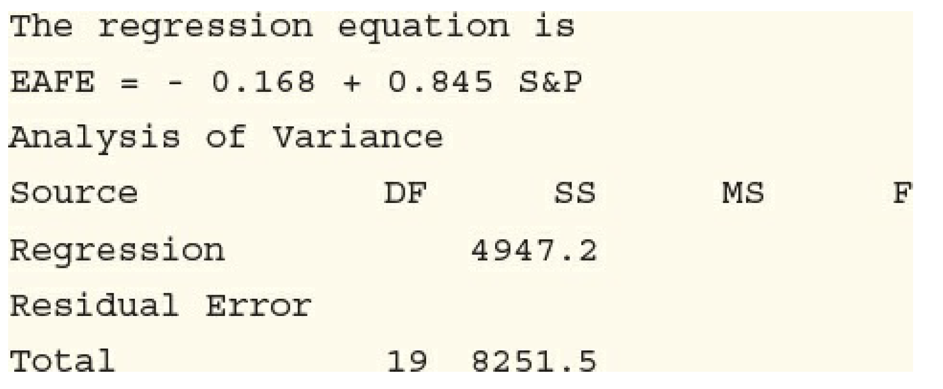

Using the ANOVA table format on page 589 as a guide, complete the analysis of variance table.

**11.37 Predicting bone formation.**

Let’s use regression methods to predict VO+, the measure of bone formation.

(a) Since OC is a biomarker of bone formation, we start with a simple linear regression using OC as the explanatory variable. Run the regression and summarize the results. Be sure to include an

analysis of the residuals.

(b) Because the processes of bone formation and bone resorption are highly related, it is possible that there is some information in the bone resorption variables that can tell us something about bone formation. Use a model with both OC and TRAP, the biomarker of bone resorption, to predict VO+. Summarize the results. In the context of this model, it appears that TRAP is a better predictor of bone formation, VO+, than the biomarker of bone formation, OC. Is this view consistent with the pattern of relationships that you described in the previous exercise? One possible explanation is that, although all these variables are highly related, TRAP is measured with more precision than OC.

**11.38 More on predicting bone formation.**

Now consider a regression model for predicting VO+ using OC, TRAP, and VO−.

(a) Write out the statistical model for this analysis including all assumptions.

(b) Run the multiple regression to predict VO+ using OC, TRAP, and VO−. Summarize the results.

(c) Make a table giving the estimated regression coefficients, standard errors, and *t* statistics with *P*values for this analysis and for the two that you ran in the previous exercise. Describe how the coefficients and the *P*-values differ for the three analyses.

(d) Give the percent of variation in VO+ explained by each of the three models and the estimate of *σ*. Give a short summary.

(e) The results you found in part (b) suggest another model. Run that model, summarize the results, and compare them with the results in part (b).